3. Design Zero-shot, One-shot, and Few-shot Prompts to Summarize an Article into 50 Words
Note: The article is not included in your question. Use the following sample article to practice, or replace it with the article given by your faculty.
Sample Article
Artificial Intelligence is becoming increasingly important in healthcare. It helps doctors analyze medical images, identify potential diseases, and study patient records. AI tools also support drug discovery and remote patient monitoring. However, healthcare organizations must address data privacy, bias, reliability, and the need for human supervision before using AI systems widely.
A. Zero-shot Prompt
Summarize the following article in exactly 50 words. Preserve the main ideas, avoid adding information not present in the article, and use clear, simple language.
Article:
Artificial Intelligence is becoming increasingly important in healthcare. It helps doctors analyze medical images, identify potential diseases, and study patient records. AI tools also support drug discovery and remote patient monitoring. However, healthcare organizations must address data privacy, bias, reliability, and the need for human supervision before using AI systems widely.
Expected Output:
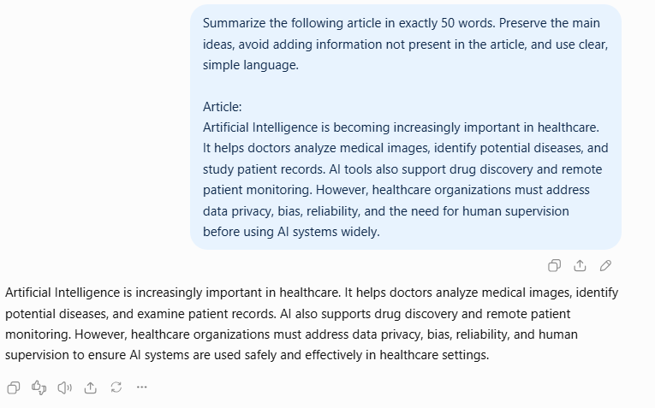
B. One-shot Prompt
Example:
Article: Solar energy converts sunlight into electricity. It reduces dependence on fossil fuels and can lower greenhouse gas emissions. However, its effectiveness depends on sunlight availability, installation costs, and energy storage.
Summary: Solar energy produces electricity from sunlight and reduces reliance on fossil fuels. Its benefits depend on sunlight, installation costs, and storage.
Now summarize the following healthcare article in exactly 50 words, preserving its main points.
Article:
Artificial Intelligence is becoming increasingly important in healthcare. It helps doctors analyze medical images, identify potential diseases, and study patient records. AI tools also support drug discovery and remote patient monitoring. However, healthcare organizations must address data privacy, bias, reliability, and the need for human supervision before using AI systems widely.
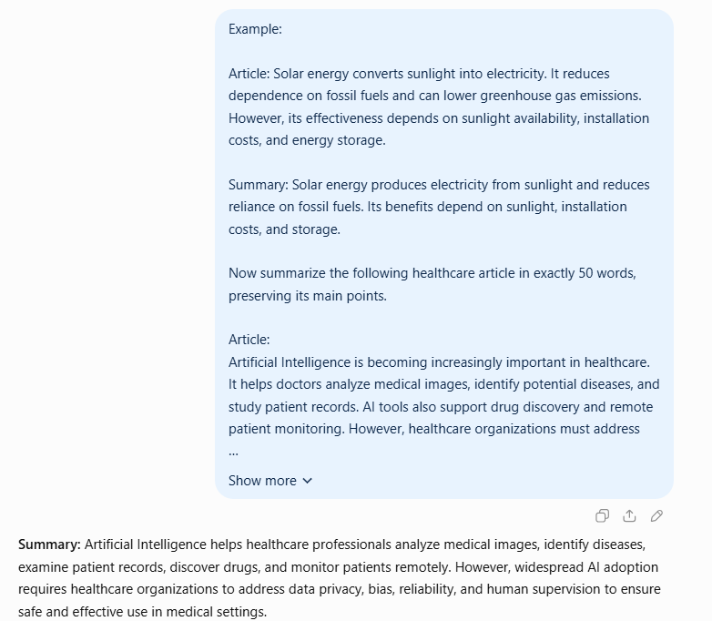
C. Few-shot Prompt
Example 1:
Article: Online learning allows students to access educational resources remotely. It provides flexibility but requires internet access and self-discipline.
Summary: Online learning provides flexible remote access to educational resources, but it depends on internet connectivity and student self-discipline.
Example 2:
Article: Electric vehicles reduce direct exhaust emissions and can lower dependence on petrol. Their adoption depends on charging infrastructure, battery costs, and electricity availability.
Summary: Electric vehicles reduce exhaust emissions and petrol dependence, but wider adoption requires accessible charging infrastructure and affordable batteries.
Now summarize this article in exactly 50 words. Preserve the key applications and challenges without adding unsupported facts.
Article:
Artificial Intelligence is becoming increasingly important in healthcare. It helps doctors analyze medical images, identify potential diseases, and study patient records. AI tools also support drug discovery and remote patient monitoring. However, healthcare organizations must address data privacy, bias, reliability, and the need for human supervision before using AI systems widely.
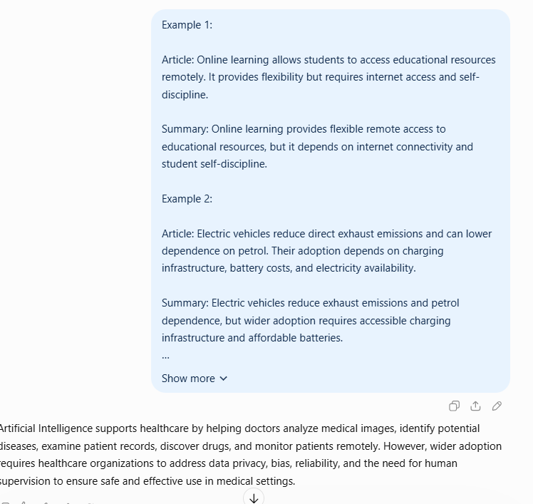
D. Comparison of Summaries
Criterion | Zero-shot | One-shot | Few-shot
Accuracy | Depends on instructions | Guided by one example | Guided by several examples
Completeness | May cover main ideas | Can follow a demonstrated pattern | Can consistently cover key points
Readability | Usually clear | Follows the example's style | Can produce more consistent wording
Result: Few-shot prompting provides more examples of the expected summary style. However, all three outputs must be checked for factual accuracy and whether they preserve the article's main points.

